LAWS 3602 International Human Rights

Instructions: Please read carefully.

This assignment comprises two sections. Both must be completed to receive a final grade.

Section 1: Multiple Choice (40 marks)

Please read the excerpt on the following page from Oren Gross’s article and answer the multiple choice question in response to the excerpt.

Remember that in answering the multiple choice questions, you need to choose the BEST answer. It may be possible that more than one answer is PLAUSIBLE, but there will be only one BEST answer; so please read the excerpt and the questions carefully before answering.

Indicate your answers in the relevant space provided below the multiple choice questions on page 4.

Section 2: Short Critical Writing (60 marks)

In 250-300 words briefly describe the main features of Oren Gross’s Extra-Legal Measures Model and then explain with at least one supporting reason if you believe the Model is a sound as a response to threats of violent crises.

All you need to do is identify one or two strengths or weaknesses in the Model. You do not need to list every possible strength or weakness. However, you must justify your answer. For example, if you think that Gross’s view of public officials as subscribing to an ‘ethic of responsibility” is naïve, then you must give an example perhaps drawn from real life or from an example within his own article to illustrate the problem. If you draw from his article, then don’t forget to cite the relevant page etc.

Write out your answer in the space provided on page 4.
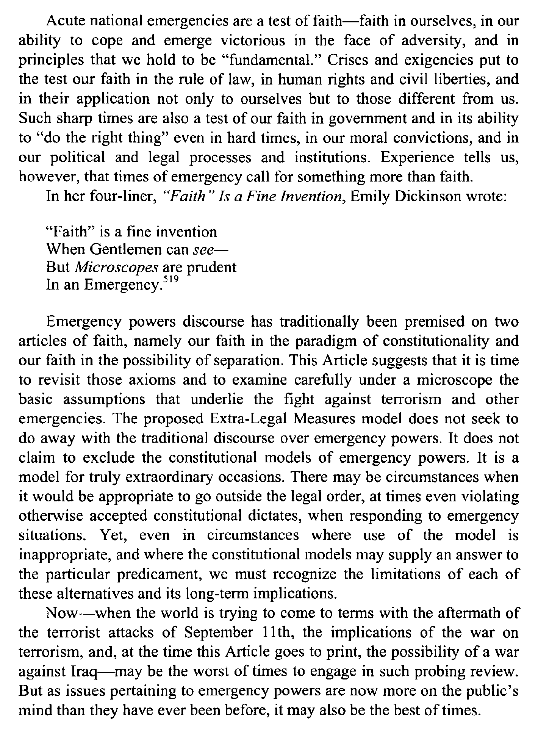

- In the first two sentences, Gross writes about “faith.” He suggests that:
- Faith and religion are important aspects of what it means to be a full human in today’s world, separating ourselves from others different from us.
- Faith is required as “fundamental” to be “victorious” over those who lack faith, uniting ourselves especially in times of crisis.
- In times of crisis it is important to have faith in our values as they apply to those both similar to us, but importantly also to those different from us.
- Times of crisis are also known as “crises and exigences” and “the face of adversity.”

2) In the two sentences immediately following the quotation from Emily Dickinson, Gross claims that:
- In times of crisis, usually we focus on constitutionality and separation, but we should also look very closely at what underlies our assumptions about emergencies.
- In emergency situations, we often get distracted by looking at two things, when instead we should focus on a microscope.
- Basic assumptions underlie things. Those basic assumptions are interesting.
- Our faith in the paradigm of constitutionalism and the possibility of separation is misguided.

3) In the portion of paragraph 2 beginning with “The proposed Extra Legal Measures Model…” and ending with “...when responding to emergency situations” suggests that the Extra Legal Measures model is:
- A solution to overlap and overtake regular emergency measures covered off in constitutional models of emergency powers.
- Seeking to offer an additional model for use in truly exceptional situations.
- A way to avoid ever solving problems by going beyond the legal order.
- Offering a rejection of typical discourse around emergency powers.

4) In the sentence declaring: “ There may be circumstances when it would be appropriate to go outside the legal order, at times even violating otherwise accepted constitutional dictates, when responding to emergency situations,” is the point of the sentence to convey:

(a)It is always necessary to go outside the law.
(b) It is sometimes necessary to go outside the law.
(c) It is sometimes necessary to go outside the law and exercise raw political power.
(d) It is sometimes necessary to go outside and break established constitutional law in order to respond to a state of emergency

5) As Gross closes out his article, he thinks that the timing of articulating his Extra Legal Measures Act is:
- Unnecessary, given 9/11
- Inappropriate, given 9/11
- Irrelevant, given 9/11
- Timely, given 9/11

Multiple Choice Answers:

1)

2)

3)

4)

5)

Section 2: Short Critical Writing (250-300 words)

